NDML KRA SFTP ACCESS AND SHARING OF DOCUMENTS AND FILES TO NDML KRA

Introduction

As a part of registration & modification process, SRIs have to share the documents for processing the KYC. NDML provides this facility through SFTP.
SFTP (Secure File Transfer Protocol) is a secure file transfer protocol that uses secure shell encryption
to provide a high level of security for sending and receiving file transfers.
NDML KRA offers SFTP access to all SRIs that utilize API-based connectivity. For those SRIs without API integration, SFTP access is granted on an individual evaluation basis.

Prerequisite

Before gaining SFTP access, it's mandatory for SRIs to register as a Market Intermediary (MI) with NDML KRA.
Registration requires submitting a filled and signed Intermediary Registration form along with the terms & conditions document.
Registration form: https://kra.ndml.in/kraweb/downloads/Intermediary_Registration_Form(AnnexureI).pdf
T &C documents: https://kra.ndml.in/kra-web/downloads/Terms%20and%20Conditions%20(Annexure%20II).pdf
These documents should be emailed to
Name | Email
Ajinkya Gaikwad | ajinkya.gaikwad@nsdl.com
Nazmeen S | nazmeens@nsdl.com
Prashant Prachand | prashantd@nsdl.com

For initiating request for grant of SFTP access, SRIs should reach out to the NDML KRA team by sending email to the following email IDs:
Name | Email
Sagar Chaukekar | sagarc@nsdl.com
Bharat Bhere | bharatb@nsdl.com
Prashant Prachand | prashantd@nsdl.com

Email for SFTP access request should have following details:
MI Name | MI ID | Name of the compliance officer of the MI | Email ID of the compliance officer | Mobile number of the compliance officer | IP address ( Public static IP) for whitelisting by NDML
(IP addresses to be whitelisted in production environment to be only provided)
File Sharing Protocol for SRIs to NDML KRA via SFTP:
To integrate KYC data with the NDML KRA system, SRIs should upload the data in the designated format either directly via the screen or through an API. For a detailed guide, SRIs can consult the KRA Operations Manual for Intermediaries at this link
After KYC data upload, SRIs should upload the associated PDF documents (like KYC application form, Proof of Identity, and Proof of Address) and XML files (such as Digilocker, Offline AADHAAR, KUA-sub KUA) to the SFTP. Once these files are added to the SFTP folder, they'll automatically link with the relevant KYC record in the NDML KRA system.

The process for upload of pdf of documents & XML files with screenshots is provided below.

Step1 : Login

SRI user need to input below details to successfully login into system, which are mentioned below and are received from NDML KRA when SFTP access is provided by NDML to the SRI.
o Host name
o Port number
o User name
o Password

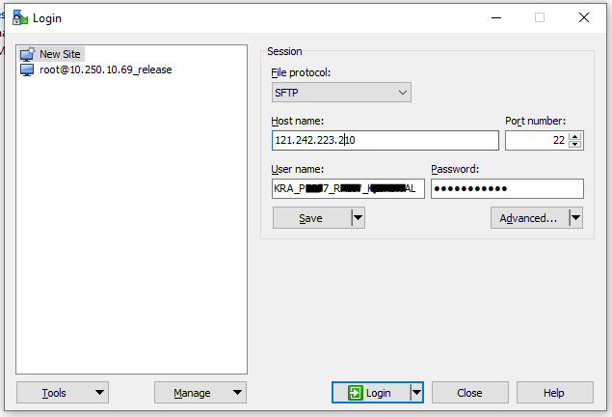

Once user enters all credential details, user has two click on Login action button.

Step 2: User Interface Post-Login

After a successful login, the system displays three distinct folders: Image Upload, XML upload and Response folder.

Users should focus on two primary folders for file placement:

1. Image Upload: Here, users should upload or copy the PDF document named as 'PAN.pdf'.
2. XML Upload: This folder is designated for XML files obtained via Digilocker, offline AADHAAR, and eKYC (sourced as subKUA/KUA from UIDAI). Files should be named 'PAN.xml' before uploading or copying.

**
3. Response folder : Response folder consist of the pdf of documents (KYC application form, Proof of Identity and Proof of Address) / Images for KYC records which are downloaded by SRI user from/through NDML KRA via API

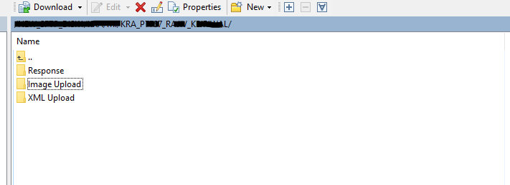

Step 3: Uploading Documents

1. PDF Documents Upload:
- Navigate to the "Image Upload" folder.
- Create a folder named by date (Format: yyyy-mm-dd).
- Inside this date folder, upload the PDF document using the naming format: PANnumber.pdf (e.g., ASDFG1234H.pdf).

2. XML Upload:
- Go to the "XML Upload" folder.
- Create a date-specific folder (Format: yyyy-mm-dd).
- Within this folder, upload the XML document named as PANnumber.xml (e.g., ASDFG1234H.xml).
** Please note that XML received from digilocker, ekYC & Offline Aadhar has to be uploaded in common folder**

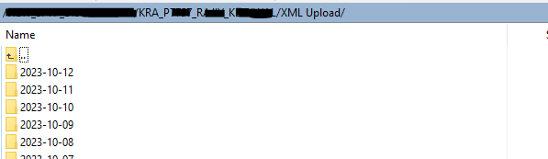

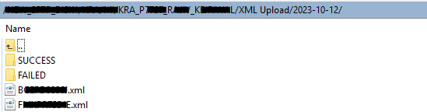

Step 4: Post-Execution of SFTP Upload Jar
Upon the execution of the SFTP Upload Jar, two folders are automatically generated:

- Success Folder: Contains files that have been successfully uploaded. Files are automatically moved here upon successful upload.
- Failed Folder: Contains files that failed to upload. Files are automatically relocated here if the upload was unsuccessful.
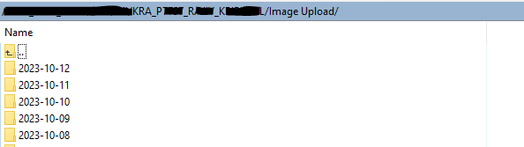
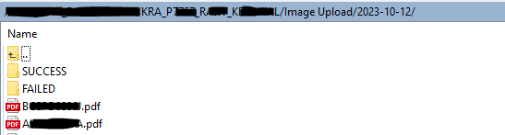

Supported Document Extensions for KYC Form: The system accepts KYC forms in the following formats: PDF, TIF, TIFF, and ZIP. It's essential to note that the system will not accept JPEG or any other formats.

Step 5 : Retrieving Responses from the System

Response Folder: After successfully downloading KYC records via API, the SRI user will receive a pdf of documents. This includes the KYC application form, Proof of Identity, and Proof of Address. Additionally, images associated with KYC records will be downloaded. These documents will be organized in date-specific folders, all of which are located under the main "Solicited" folder.

